AI Assisted Coding
Practices Assignment -6.1
Name : Omprakash.
HT No : 2303A52057
Batch No : 39
Practice Assignment -2
A supermarket wants to automate its monthly sales analysis system using a Python program to help the manager understand product-wise and day-wise sales performance. You are required to develop a console-based application that uses multiple loops to process sales data.
The program should first ask for the number of days in the month and then, for each day, ask for the number of products sold. Using a nested loop structure, the program should accept the name of each product and the quantity sold on that day.
The program must calculate the total quantity sold for each product across all days and also compute the overall sales quantity for the entire month. After processing all inputs, the program should display a clear summary showing day-wise sales, product-wise totals, and the grand total sales for the month. The system should allow the manager to repeat the analysis for another month if required.
Prompt :
#Write a Python console program using nested loops to accept day-wise and product-wise sales data for a month, calculate day-wise totals, product-wise totals, and the grand total sales, and allow repeating the analysis for another month.
Code :
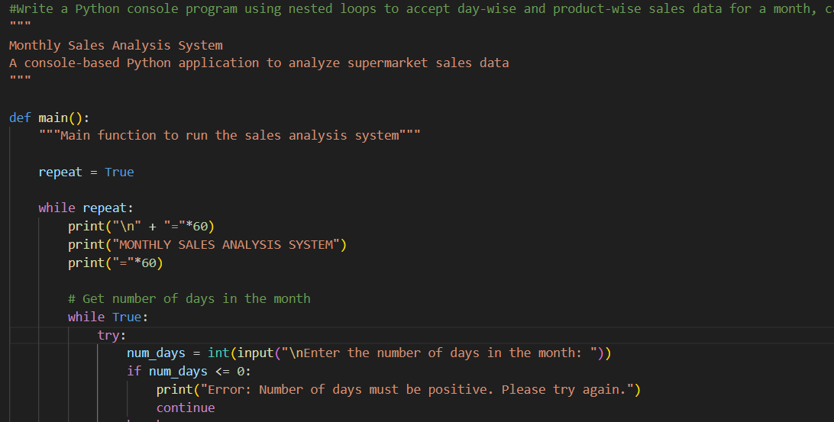
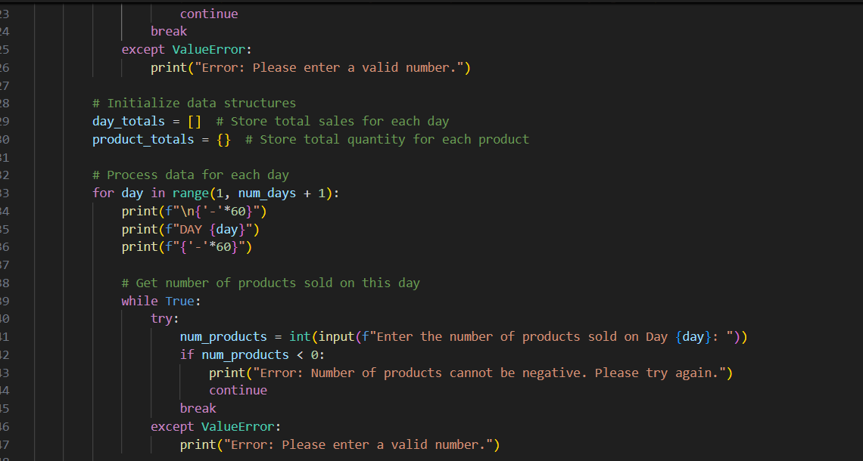
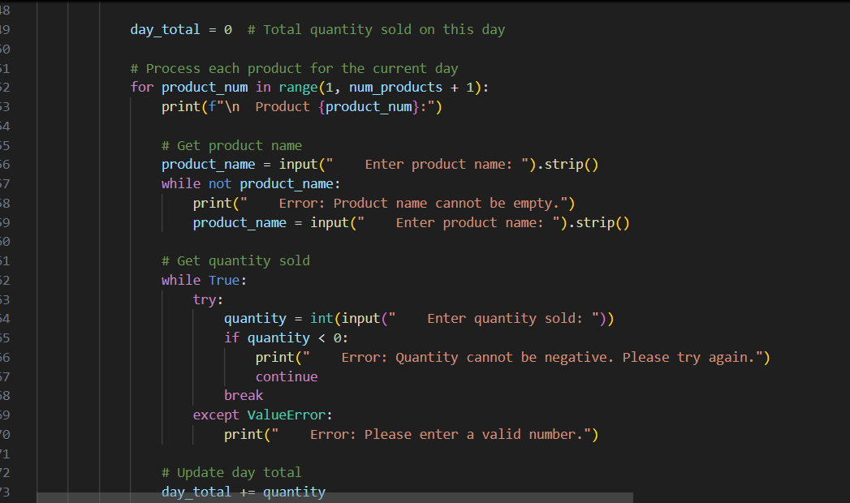
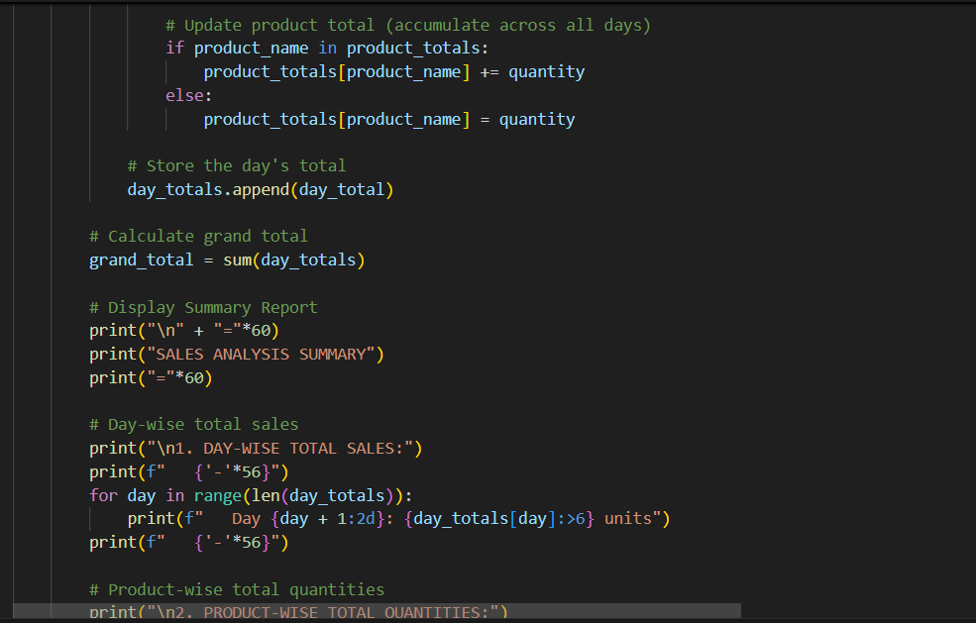
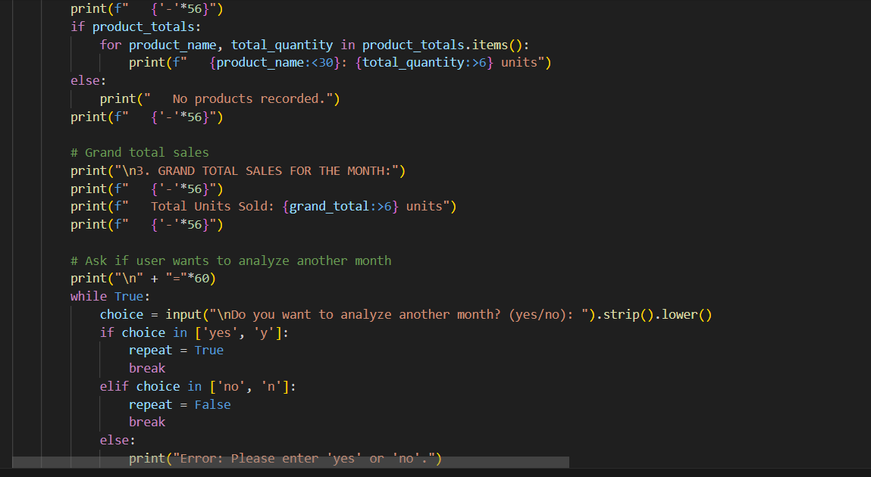
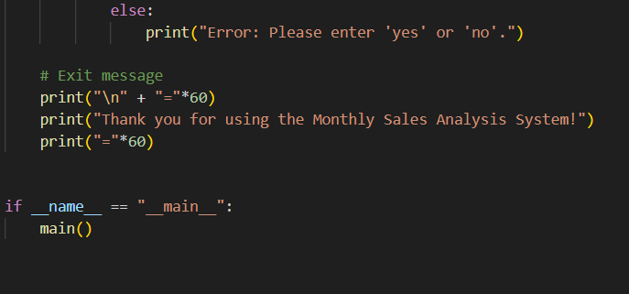
OUTPUT :
